**Research Server User Guide**

Introduction

The research servers are powerful computing tools which provide Brookings staff and affiliates with dedicated hardware for processor and memory intensive data analysis.

What is a Research Server?

A research server is a powerful computer that you can remotely log into in order to perform your work. The server opens up in its own window on your desktop and looks like a regular Windows machine. However, any computations you perform are run on the research server, rather than being run locally on your machine. ITS supports two dedicated research servers: Research05 & Research06.

Instructions for Access

To use the research servers, contact your financial manager or ITS Liaison and ask them to submit a [Hardware/Software Request Form](http://intranet.brookings.edu/its0/Services/Hardware/Purchase/nonstandardform/non-standard.htmhttp:/intranet.brookings.edu/its0/Services/Hardware/Purchase/nonstandardform/non-standard.htm) requesting access to the research servers on your behalf. It takes a few days for the ITS Service Desk to configure your access, so please plan accordingly.

To log on to the research servers from your Brookings desktop:

1. The ITS Service Desk will send you configuration files to access the Research Servers when your access is granted.
2. Save the files to your desktop for easy access.
3. Double-click to launch the remote session and login with your Brookings credentials.

To log on to the research servers from home:

1. Access the files the ITS Service Desk sent you from Webmail (webmail.brookings.edu) or MyRemote email.
2. Save the files to your home PC desktop for easy access.
3. Double-click to launch the remote session and login with your Brookings credentials.

Where should I store my data?

Researchers have several options for storing quantitative data sets. The following table lists and describes the different drives available to research server users:

|  |  |  |  |  |  |
| --- | --- | --- | --- | --- | --- |
| **Drive** | **Description** | **Speed** | **Capacity** | **Cost for storage?** | **Recommended for data storage?** |
| **C:** | Research Server hard drive | Moderate | 1 GB | No | **NO** |
| **N:** | Program folder on network drive | Moderate | Large | Cost for storage over 5GB/user quota |
| **R:** | Temporary storage for use when actively processing data. **Local to RS05.** | Fast | Medium | No | **YES** |
| **S:** | Temporary storage for use when actively processing data. **Local to RS06.** | Fast | Medium | No |
| **V:** | Destination for long-term data storage. | Moderate | Large | No |

Drive Mapping

The R: and S: drives are directly connected to the research servers via fast fiber optic connections and should be your primary locations for storing and accessing data for your active projects. The V: drive is connected via a slower ethernet connection and should be used for long term storage.

**Research05**

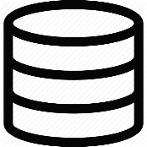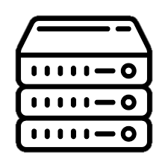

R: Drive

V: Drive

Ethernet

Cable



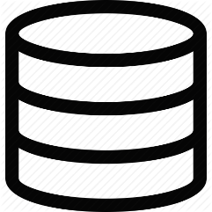

C: Drive (Research05)

**Research06**



S: Drive



Ethernet

Cable



C: Drive (Research06)

Maximizing Performance

**Shared Resources:** The research servers are shared resources so their speed is directly related to the number of users utilizing them at a given time. If one server is behaving slowly, consider logging into one of the other servers, which may have fewer active users. Please be respectful of these shared resources and be sure to clear any temp files and close open sessions of programs when you are done with them.

**Data Location:**

Where you store your data affects how quickly your code will run. We recommend that folks utilize the V: drive for long-term data storage, but for fastest performance, you should move your data to the R: drive on RS05 and the S: drive or RS06 while you are actively working on your project. Just make sure you move it back after you are finished as space is limited.

The R: and S: drives are much faster than the V: drive because they are local to the servers, meaning that your data doesn’t have to travel as far to get from the storage location to the processor. Note that the R: drive is meant for use with Research 05 and the S: drive for use with Research 06. Make sure you use the appropriate drive for storage to achieve the best performance.

Hardware

ITS supports two dedicated research servers: Research05 & Research06

|  |  |  |
| --- | --- | --- |
|  | **Research05** | **Research06** |
| **Processor:** | 2 x 2.5 Ghz | 2 x 2.5 Ghz |
| **RAM:** | 96 GB | 128 GB |
| **Operating System:** | 64 Bit Server 2016 | 64 Bit Server 2016 |
| **Storage:** | 5 TB (R:) Drive | 5 TB (S:) Drive |

Users who are members of the ‘Research Drive’ Group have personalized folders to save their personal scratch files within the ‘Users’ folder on the R: and S: Drives.

Available Software

The following software is available via the research servers:

|  |  |  |
| --- | --- | --- |
| Adobe Pro | Java | R Studio |
| Adobe Reader | Wolfram Mathematica | SAS |
| Anaconda | Microsoft Office | SPSS |
| ArcGIS | Python | Stat Transfer |
| EViews | R | Stata |
| Gauss | Repast Simphony | WinZip |